DC circuits with diodes and resistors
- Assume a constant voltage drop model for the diodes with a cut-in voltage of 0.7V.
- Write your answers in the table shown on the next page.
- On a separate page, show your work for each problem. Denote the bias of all diodes by writing FB/RB next to forward/reversed biased diodes respectively.
- Write “unknown” for circuits whose current/voltage cannot be determined.
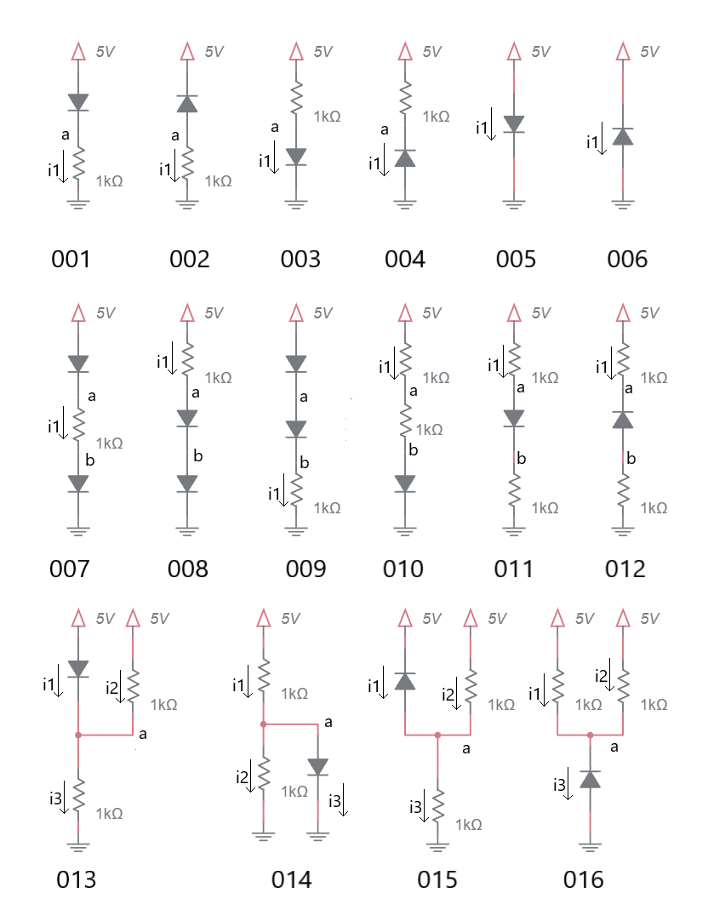
Problem |  | a | b | i1 | i2 | i3
001
002
003
004
005
006
007
008
009
010
011
012
013
014
015
016

Current Source circuits with diodes and resistors
Determine the currents and voltages in the following circuit.
- Assume a constant voltage drop model for the diodes with a cut-in voltage of 0.7V.
- Write your answers in the table shown on the next page.
- On a separate page, show your work for each problem. Denote the bias of all diodes by writing FB/RB next to forward/reversed biased diodes respectively.
- Write “unknown” for circuits whose current/voltage cannot be determined.
- Note, the current source energizing all the circuits!

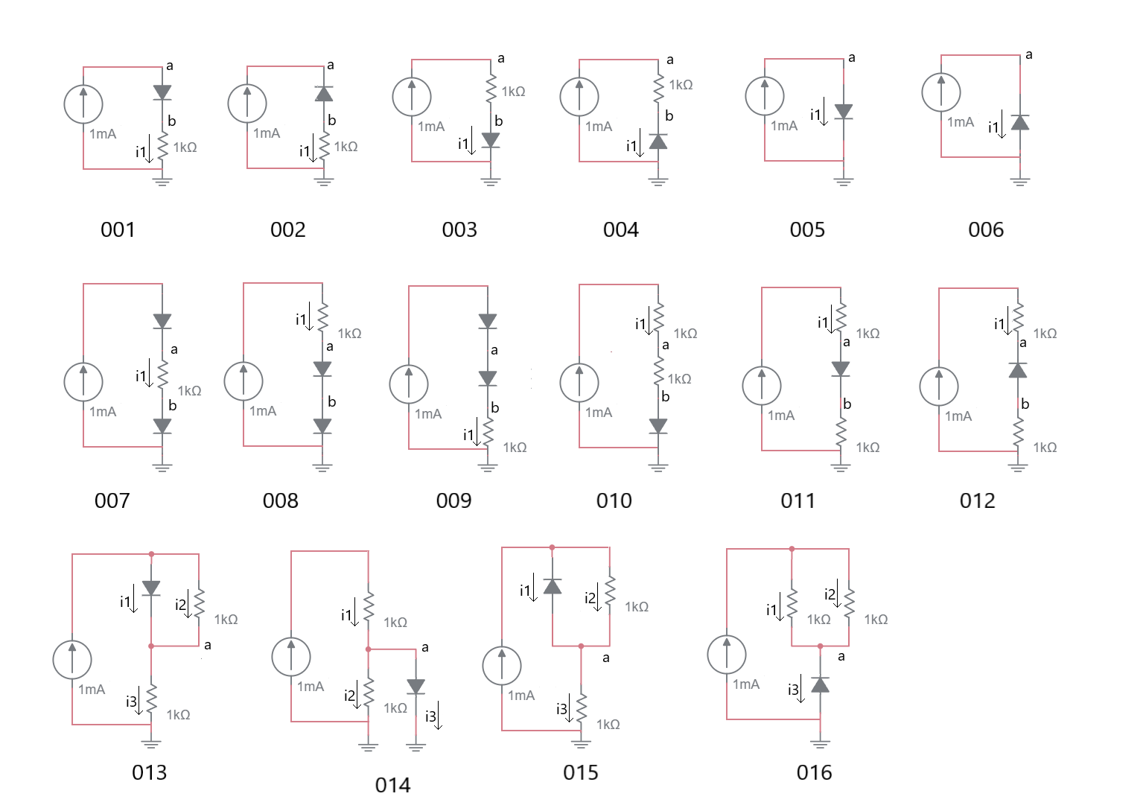

Problem |  | a | b | i1 | i2 | i3
001
002
003
004
005
006
007
008
009
010
011
012
013
014
015
016

DC circuits with diodes and resistors
- Assume a constant voltage drop model for the diodes with a cut-in voltage of 0.7V.
- Write your answers in the table shown on the next page.
- On a separate page, show your work for each problem. Denote the bias of all diodes by writing FB/RB next to forward/reversed biased diodes respectively.
- Write “unknown” for circuits whose current/voltage cannot be determined.
- Note, the power rails are a mix of 5V and 10V!

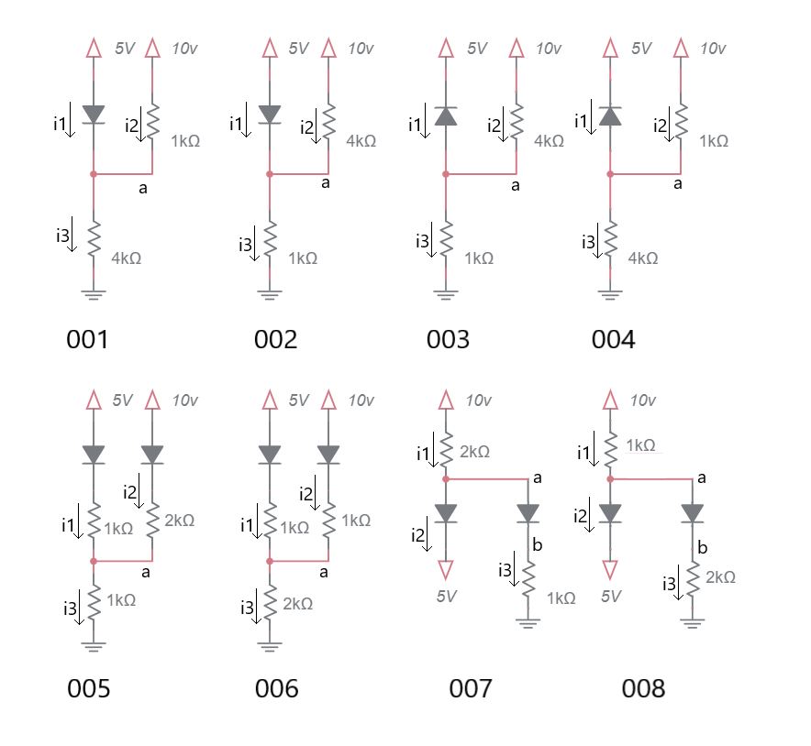

Problem |  | a | b | i1 | i2 | i3
001
002
003
004
005
006
007
008

Diodes as logic gates
In the following circuits consider 5V logic 1 and GND as logic 0. Use the ideal diode model for analysis. Complete the truth table for the circuit shown and describe the logic function instantiated by each.

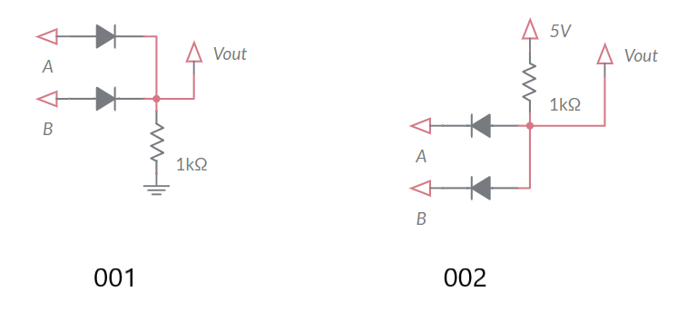
A | B | Vout
0 | 0 | 0
0 | 1 | 1
1 | 0 | 1
1 | 1 | 1
A | B | Vout
0 | 0 | 0
0 | 1 | 0
1 | 0 | 0
1 | 1 | 1

AC circuits with diodes and resistors
For each of the circuits below, complete the timing diagrams.
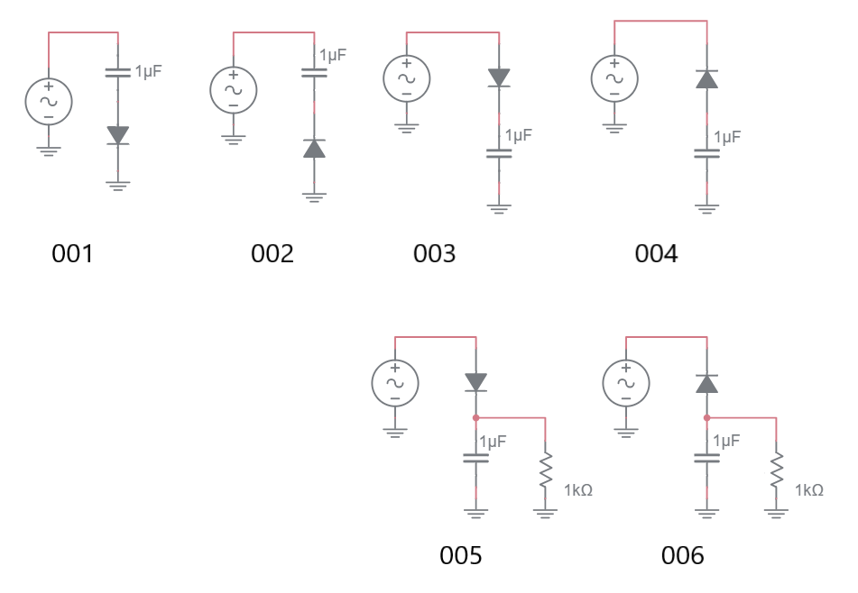
After you complete the timing diagrams for circuits 001 to 004, look at their behavior and assign the circuits one of the following names – one name for each circuit.
- Peak detector __________
- Positive level shifter __________
- Trough detector __________
- Negative level shifter __________

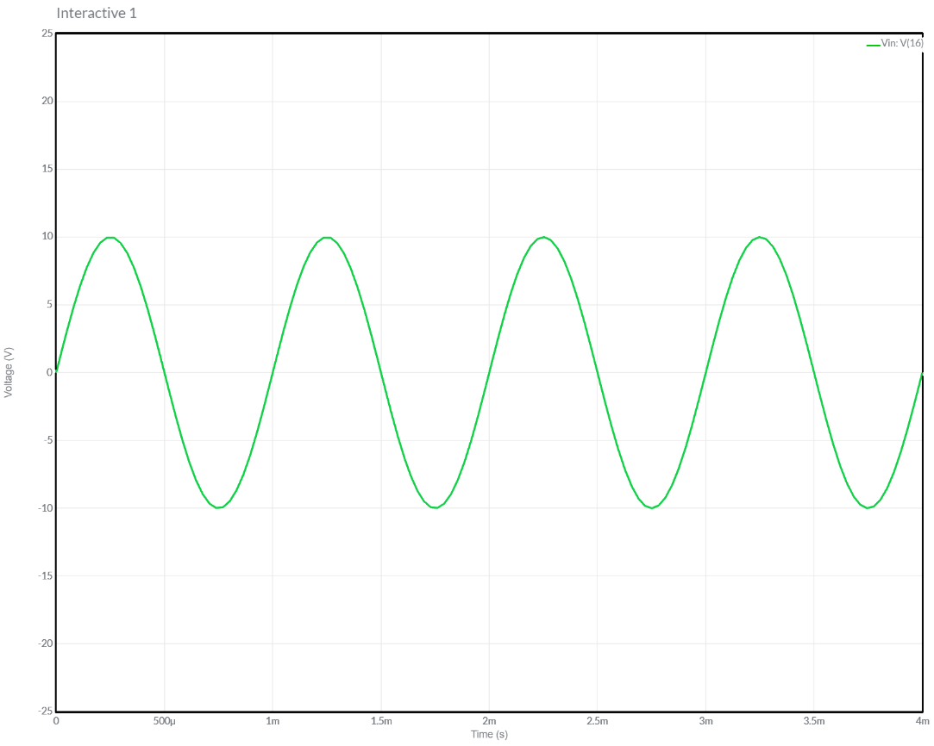
Plot the voltage for the circuit labeled 001.


Plot the voltage for the circuit labeled 002.

Plot the voltage for the circuit labeled 003.


Plot the voltage for the circuit labeled 004.

Plot the voltage for the circuit labeled 005.

Plot the voltage for the circuit labeled 006.

Special Types of Diodes – The Zener Diode
The Zener diode shown below is first and foremost a diode. In the I/V graph below, the forward biased Zener diode starts conducting current at V_{F}, typically about 0.7V. However, Zener diodes have a trick, when the reverse biased voltage exceeds the Zener diodes’ Zener voltage it conducts current from the cathode to the diode while clamping the voltage at the Zener voltage -V_{Z}. Manufactures of Zener diodes produce them with a variety of Zener voltages. In order to maintain a clamped reverse biased voltage, a Zener diode must pass at least -I_{Z} amps, the minimum Zener current.
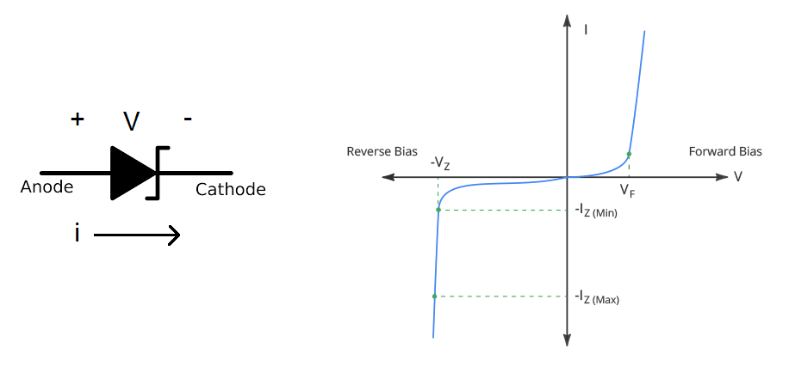

Practical Application – Voltage Doubler
The circuit below takes combinations of circuits from the AC circuits with diodes and resistors section and combines them to produce a larger voltage than the input voltage. Before starting on this analysis, you must first have successfully completed all the problems in the AC circuits with diodes and resistors section.
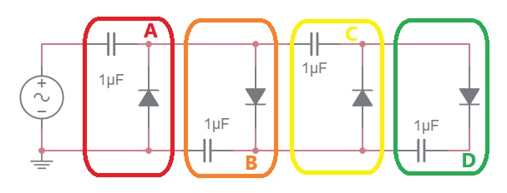
- Look at the circuit outlined in red and compare it to circuits 001 to 004 in the AC circuits with diodes and resistors section. Which circuit is it and what name did you assign it?

- The circuit outlined in orange gets it input from A. Look at the circuit outlined in orange and compare it to circuits 001 to 004 in the AC circuits with diodes and resistors section. Which circuit is it and what name did you assign it?

- The circuit outlined in yellow gets it input from A and its ground terminal is connected to B. Look at the circuit outlined in yellow and compare it to circuits 001 to 004 in the AC circuits with diodes and resistors section. Which circuit is it and what name did you assign it?

- The circuit outlined in green gets it input from C and its ground terminal is connected to B. Look at the circuit outlined in green and compare it to circuits 001 to 004 in the AC circuits with diodes and resistors section. Which circuit is it and what name did you assign it?

Use this information to plot the output of each colored stage given the input shown.
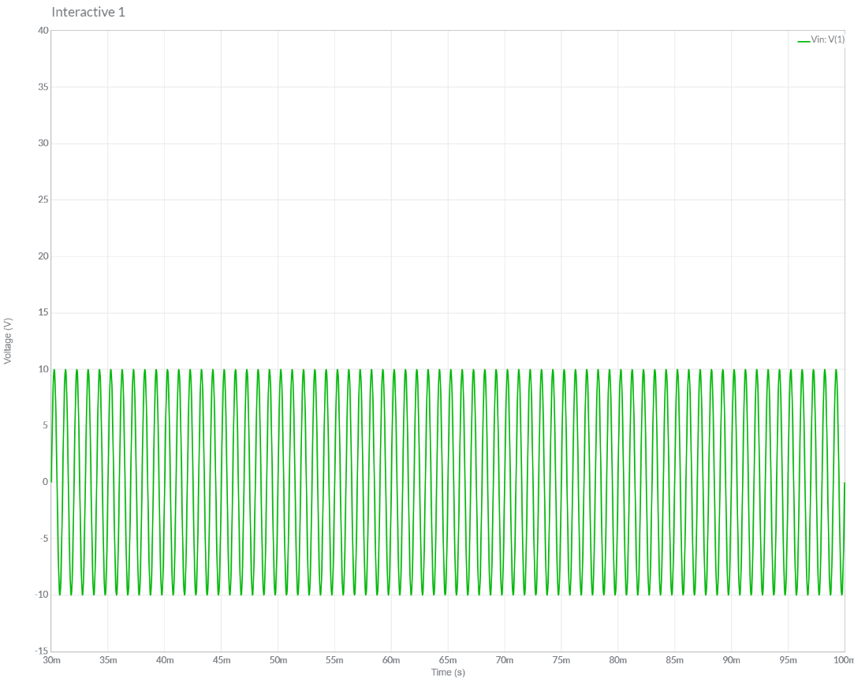

Practical Application – I/V Curve for LED
You are required to illuminate a Cree Xlamp XM-L2 High Power LED using either a current source or voltage source, the choice is yours. The LED has a I vs. V curve is shown in Figure 1. You are tasked to operate the LED at 3V and 1.3A – the point in the middle of the curve.
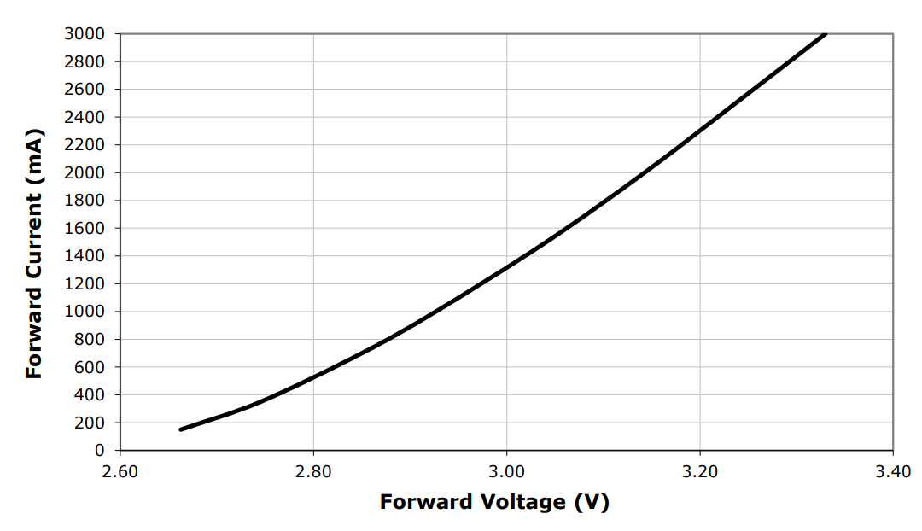
Figure 1: I/V curve for a Cree Xlamp XM-L2 High Power LED.
Compute the variation in power using a voltage source with a ±10% variation in voltage.
- Using this voltage source, what is the range of voltages across the LED?

- Using the I/V curve in Figure 1, what is the range of current through the LED?

- What is the range of power dissipated by the LED voltage source?

Compute the variation in power using a current source, with a ±10% variation in current.
- Using this supply, what is the range of current through the LED?

- Using the I/V curve in Figure 1, what is the range of voltage across the LED?

- What is the range of power dissipated by the LED using the current source?

What supply (voltage and current) produces the least variation in power?

What characteristic of the I/V curve determines the sensitivity to changes in voltage or current?

Practical Application – Using diodes as a switch
The following circuit shows how you can use a diode to switch a (small) AC signal on or off.

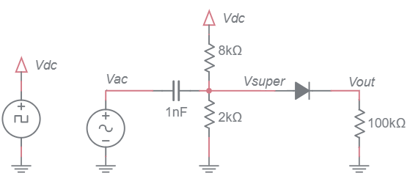
Your first task is to determine the signal Vsuper from the Vac and Vdc signals. To do this ignore the diode and the 100kΩ resistor and use superposition to determine Vout. Note that the Vdc signal is a square wave that alternates between 0V and 10V at 10kHz (see graph below). If you are having a problem with this open the workbook to the Review section and find the Practical Application – Coupling AC signal on a DC bias section. You could also use the simulator for some hints.
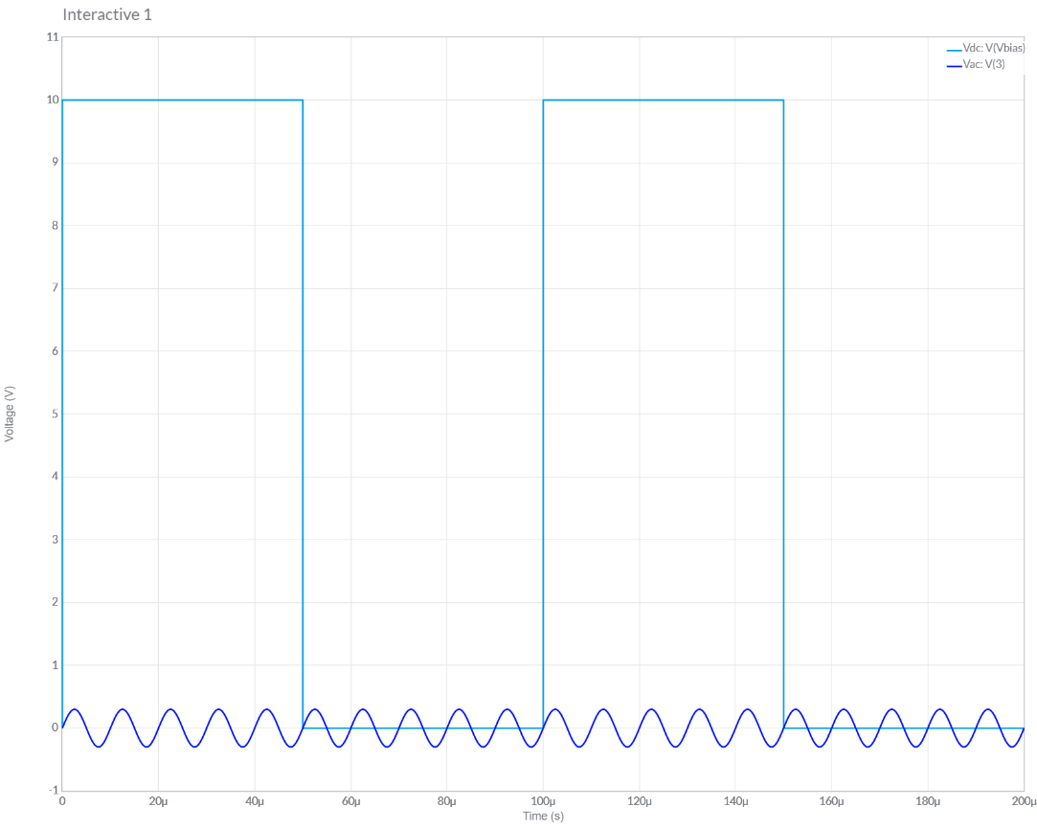
Note compute the Vout by running the Vsuper signal through a diode modeled as a constant voltage drop. You should see that when the Vdc signal is at 10V the AC signal passes through to Vout. When the Vdc signal is at 0V, Vout = 0V.

